Test Documentation

For

Carpool Project

Prepared By: Eric Borisow, Ty Huynh, Geoff Scholl
SWENG 500 – Software Studio
June 28, 2009

Table of Contents
1. Introduction 4
1.1 Objectives 4
1.2 Background 4
1.3 Scope 4
1.4 Test Items 4
1.5 Features to be tested 5
1.6 Features not to be tested 5
1.7 Approach 6
1.8 Item pass/fail criteria 6
1.9 Suspension criteria and resumption requirements 6
1.10 Environmental Needs 6
Functional Test Procedures 8
2. TC-01 – Logon 9
2.1 Purpose 9
3. TC-02: Search 11
3.1 Purpose 11
4. SD05-03: Column Attribute Test 13
4.1 Purpose 13
4.2 Special Requirements 13
4.3 Procedure Steps 13
5. SD05-04: Title Attribute As JavaBean Test Case 15
5.1 Purpose 15
5.2 Special Requirements 15
5.3 Procedure Steps 16
6. SD05-05: Title Attribute Test Case 17
6.1 Purpose 17
6.2 Special Requirements 17
6.3 Procedure Steps 18
7. SD05-06: Invalid List Object Test Case 19
7.1 Purpose 19
7.2 Special Requirements 19
7.3 Procedure Steps 19
Test Results 21
8. Functional Test Results 23
8.1 Description 23
8.2 Testing Results 23
8.3 Sample Report 24
9. Structural Test Results 27
9.1 Description 27
9.2 Testing Results 27
10. Test Incidents 29
10.1 SD06-01 – Invalid List Object Incident 29
10.1.1 Summary 29
10.1.2 Incident Description 29
10.1.3 Impact 29
10.2 SD06-02 – Invalid PageContext Attribute Test Case 29
10.2.1 Summary 29
10.2.2 Incident Description 30
10.2.3 Impact 30
10.3 SD06-03 - ExcludedParams parameter contains ‘myParam, *’ value 30
10.3.1 Summary 30
10.3.2 Incident Description 30
10.3.3 Impact 31
10.4 SD06-04 - RequestURI is not null, dontAppendContext is false 31
10.4.1 Summary 31
10.4.2 Incident Description 31
10.4.3 Impact 31
Appendix A – References 32
Appendix B – Sample JSP Test Page 33
Appendix C – Sample Test Case class 34

Introduction

Objectives
This document is composed of multiple documents that describe the testing activities that were performed on the Carpool project. The documents were combined to provide a concise description of a subset of the testing that could be performed to verify the requirements of the product. This document contains a test plan, the functional tests, the module tests, the test results and the incident reports for errors that were uncovered.
The first section of the document contains the test plan. The test plan is comprised of some basic information about the project, the list of features that will be tested, the features that will not be tested and some general information about the approach for performing the tests.
The second section contains the Test Specifications. The third section contains the Module Test Specifications and the final section contains the Test Results.

Background
The Carpool software is essentially an application on the Blackberry that generates carpool schedule from existing members. The application gathers the home location of registered users and generates a list of users near the proximity.
As part of an assignment, we took the Carpool system and created tests to exercise the functions of the software. The tests are based on a subset of requirements of the software.

Scope
The scope of the test will include the login process, create trip, and search for existing trips. The login will consist of the success and failure of the login process. The test of the create trips consist of success case and failure case, and also verification of trips being created. Testing existing trips consist of examining trips in the database matching up with existing trips on the carpool application.

Test Items
The version of Carpool that is under test is version 1.1. The following table represents the traceability matrix between tests and requirements.

Test Cases/Req ID | 3.2.2.1 | 3.2.2.2 | 3.2.2.3 | 3.2.2.4 | 3.2.2.5 | 3.2.2.6 | 3.2.2.7 | 3.2.2.8 | 3.2.2.9 | 3.2.2.10 | 3.2.2.11 | 3.2.2.12 | 3.2.2.13 | 3.2.2.14 | 3.2.2.15
SD05-01 |  |  | x |  |  |  |  |  |  |  |  |  |  |  | x
SD05-02 | x |  |  | x | x
SD05-03 |  |  |  |  | x | x
SD05-04 |  |  |  |  |  |  |  | x
SD05-05 |  |  |  |  |  |  | x
SD05-06 |  |  | x
SD05-07 |  |  |  |  |  |  |  |  | x
SD05-08 |  |  |  |  |  |  |  |  |  | x
SD05-09 |  |  |  |  |  |  |  |  |  |  | x
SD05-10 | x |  |  |  |  |  |  |  |  |  |  | x
SD05-11 |  |  |  |  |  |  |  |  |  |  |  |  | x | x
SD05-12 |  |  |  |  |  |  |  |  |  |  |  |  |  | x
Table 1 - Traceability Matrix

The following documents were used as sources of information for the test plan:
- SR01-01 - Requirements Document
- Display Tab web site (http://displaytag.sourceforge.net)

Features to be tested
The following functions will have tests specified in this document.
- Login
- Create new trip
- Search existing trip

Features not to be tested
The following functions of Carpool are not defined in the requirements and are not covered here:
- Register new user

Approach
This test plan will use two approaches to testing the Carpool software. The approach is the nominal (success) case. The Black Berry Simulator can be used to test all the nominal cases. For non-nominal (failure) cases, test methods will have to be created to execute the paths.
The nominal testing of the Carpool software can be tested using scenario base testing. Multiple test case scenarios can be performed to verify the requirements. Non-nominal cases can be executed test methods to exercise the functionality of the system. Since checking the results visually is error-prone and imprecise, we will utilize a unit testing framework that is designed for testing. To do that, we will use the jUnit testing framework combined with the Blackberry simulator framework.
The test methods contain the logic that performs assertions. These assertions will test the output generated to ensure that the response received is correct. A report will then be generated containing all of the results.

Item pass/fail criteria
For nominal cases, the Black Berry simulator can used to verify the pass or fail criteria. Verification can be performed by examining the screen on the Black Berry screen.
For non-nominal cases, there are specific assertions that are tailored for each test. These assertions will check to make sure that the page rendered contains the correct data. When each test is run, the test runner will report any failures and the cause of failure. If an error occurs for a particular test, then the test is considered failed. A successful test is one where all of the assertions for the test complete without errors.

Suspension criteria and resumption requirements
All tests will be run using the Black Berry Simulator and Junit for carpool application. The tests will only be suspended if an error prevents all tests from running. If this type of error occurs, testing will be suspended until the source code is fixed or the test program is adjusted. We are not expecting an error to occur that would bring down the program.

Environmental Needs
The Carpool system is designed to run on the Blackberry connection to the Tomcat Server. The following are required to run the tests:
- Any operating system that supports Sun’s JRE 1.5
- Eclipse 3.4.2
- Apache Tomcat 5.5
- JUnit 3.8
- MySQL
- BlackBerry Smartphone Simulators 4.5.0
- Access to the Internet

Functional Test Procedures

TC-01 – Logon

Purpose
This test case provides the steps that to log onto the Carpool application for failure and success case. The test outlined here will exercise requirement #3.2.2.1 and #3.2.2.2.

Black Berry Simulator Procedures

Test Case 1: Logon using Simulator
Steps | Description | Results | Fail/Success
1. | On the Logon screen, leave the user id and password blank, and then press the Login button | The user id and password is require error appears | Success
2. | On the Logon screen, leave the user id blank and enter a password, and then press the Login button | The user id is require error appears | Success
3. | On the Logon screen enter the user id as eborisow and leave a blank password, and then press the Login button | The password is require error appears | Success
4. | On the Logon screen enter the user id as test and enter the password as test, and then press the Login button | The user can not be found error appears | Success
5. | On the Logon screen enter the user id as eborisow and enter the password as test, and then press the Login button | There user can not be found error appears | Success
6. | On the Logon screen enter the user id as eborisow and enter the password as password, and then press the Login button | Continue onto the Carpool screen | Success

jUnit Procedures

Test Case 1: Logon using jUnit
Steps | Description | Results | Fail/Success
1. | Execute the TestServiceStubScenario class with jUnit | The testLoginSuccess and testLoginFailure executed successfully. | Success

Assertion Result:
Method name | Assertion | Description | Expected Result
testLoginSuccess | Return value is not equal to 6000 | Test to ensure logon and password is correct | True
testLoginFailure | Return value is 6000. The value 6000 represent an error | Test to ensure the password is incorrect. | True

TC-02: Search

Purpose
This test case provides the steps to searches existing trips base on user id, all trips, and trips by date for Carpool application. It will also display the detail of the trip, and the mapping of the trip’s start and destination onto map. The test outlined here will exercise requirement from 3.2.2.2 to 3.2.2.10.

Black Berry Simulator Procedures

Test Case 2: Search trips using Simulator
Steps | Description | Results | Fail/Success
1. | On the Carpool screen, select Search | Continue to the Search screen | Success
2. | On the Search screen, select Show my trips | Continue to the Results screen with a list of trips | Success
3. | On the MySQL prompt, enter the following query: SELECT TITLE,START_DATE_TIME from TRIPS,USERS,TRIPS_MEMBERS where (USERS.USER_NAME='eborisow' and USERS.ID=TRIPS_MEMBERS.MEMBER_ID and TRIPS_MEMBERS.TRIP_ID=TRIPS.ID); | The query result matches the list of trips on the Results screen | Success
4. | On the Results screen, select the back key | Continue back to the Search screen | Success
5. | On the Search screen, select Show all trips | Continue to the Results screen with a list of trips | Success
6. | On the MySQL prompt, enter the following query: SELECT TITLE,START_DATE_TIME from TRIPS; | The query result matches the list of trips on the Results screen | Success
7. | On the Results screen, select the back key | Continue back to the Search screen | Success
8. | On the Search screen, select Find my trips by Date | Continue to the Search screen with the today date | Success
9. | On the Search screen, enter a date from an existing trip, and then select search | Continue to the Results screen with a list of trips | Success
10. | On the MySQL prompt, enter the following query: SELECT TITLE,START_DATE_TIME from TRIPS,USERS,TRIPS_MEMBERS where (USERS.USER_NAME='eborisow' and USERS.ID=TRIPS_MEMBERS.MEMBER_ID and TRIPS_MEMBERS.TRIP_ID=TRIPS.ID and (TRIPS.START_DATE_TIME LIKE '<date>%')); | The query result matches the list of trips on the Results screen | Success
11. | On the Results screen, select the back key | Continue back to the Search screen | Success
12. | On the Search screen, select Find all trips by Date | Continue to the Search screen with the today date | Success
13. | On the Search screen, enter a date from an existing trip, and then select search | Continue to the Results screen with a list of trips | Success
14. | On the MySQL prompt, enter the following query: SELECT TITLE,START_DATE_TIME from TRIPS where (START_DATE_TIME LIKE '<date>%'); | The query result matches the list of trips on the Results screen | Success
15. | On the Results screen, select any of the trip | Continue to the Details screen with the detail information of the trip. | Success
16. | On the Details screen, select the Black Berry Key | The Map it! popup window appears | Success
17. | The Map it! popup window, select Map it! | Continue to the map screen with the start and destination location balloon marking. The drawn out route in blue from the start to destination. Yellow balloon marking indicates roads to take. | Success
18. | On the map screen, hover the red + mark over the yellow balloon. | The popup window appears indicating the road to turn and the distance. | Success

jUnit Procedures

Test Case 1: Logon using jUnit
Steps | Description | Results | Fail/Success
1. | Execute the TestServiceStubScenario class with jUnit | The testLoginSuccess and testLoginFailure executed successfully. | Success

Assertion Result:
Method name | Assertion | Description | Expected Result
testLoginSuccess | Return value is not equal to 6000 | Test to ensure logon and password is correct | True
testLoginFailure | Return value is 6000. The value 6000 represent an error | Test to ensure the password is incorrect. | True

SD05-03: Column Attribute Test

Purpose
This test describes the necessary steps to follow to test the system’s ability to define a specific column and output only the contents of that single column. The test shall contain an object that contains several elements and this test will determine if the columns that have not been specified are correctly ignored.

Assertion | Description | Expected Result
Number of tables returned is equal to 1 | Test to make sure that the system produces 1 table containing our data. | True
Response text contains ‘There are no results.’ | The system will not display the default empty set message. | False
Check that column size is equal to 1. | In this test, we only want to display 1 column. | True
Check that the total number of rows is 2. | The system should return the header row containing the column names and a row with our data. | True

This specification covers requirement #3.2.2.5 and #3.2.2.6.

Special Requirements
To run this test, the system must be installed on a Java EE application server. The Java Development Kit (JDK) must be level 1.3 or above. The system requires Maven version 2.0.4.

Procedure Steps

Log
Record the execution of this test using the standard test log.

Setup
- Install the application Web Application Archive (WAR) file on the application server.
- Prepare the jsp file for testing by providing the appropriate objects in the jsp file.
- Initialize the HTTP Servlet runner that will be used to execute the jsp test page.
- Create a mock object that contains several row objects. The row objects shall contain 2+ properties that are considered columns.
- Specify the first property of the mock object as the column to the Carpool table property.

Proceed
- Execute the maven program using the –test parameter on jsp file /test/resources/standard/sd05_03.jsp.
- Inject the mock test object into the test and pass to test class.

Measure
- Open the TEST-org.displaytag.test.TestAll.xml in the \displaytag\target\surefire-reports\ directory.
- Verify the status of the test by locating the test case.
- If an error is displayed, view the file org.displaytag.test.TestAll.txt at \displaytag\target\surefire-reports\.
- Record additional debug information from the junit.log file.

Tear-down
- Stop the ServletRunner.
- Remove the WAR file from the application server.

SD05-04: Title Attribute As JavaBean Test Case

Purpose
This test specification shall test the system’s capability to add a title heading to a column for an HTML table. This test will measure the behavior of the system when no title attribute is specified. The system requirement is to produce a column heading that contains the name of the property displayed in proper case.

Assertion | Description | Expected Result
Number of tables returned is equal to 1 | Test to make sure that the system produces 1 table containing our data. | True
Response text contains ‘There are no results.’ | The system will not display the default empty set message. | False
Check that column size is equal to 3. | This test will display 3 columns. | True
Check that the total number of rows is 2. | The system should return the header row containing the column names and a row with our data. | True
Check row 0, column 0 for the value “Red” | The system should read the property name and set it to the header in proper case. | True
Check row 0, column 0 for the value “Blue” | The system should read the property name and set it to the header in proper case. | True
Check row 0, column 0 for the value “Yellow” | The system should read the property name and set it to the header in proper case. | True

The test outlined here will exercise the requirement #3.2.2.8.

Special Requirements
To run this test, the system must be installed on a Java EE application server. The Java Development Kit (JDK) must be level 1.3 or above. The system requires Maven version 2.0.4.

Procedure Steps

Log
Record the execution of this test using the standard test log.

Setup
- Install the application Web Application Archive (WAR) file on the application server.
- Prepare the jsp file for testing by providing the appropriate objects in the jsp file.
- Initialize the HTTP Servlet runner that will be used to execute the jsp test page.
- Create a test mock object that contains 3 simple elements (colors): red, blue, yellow.
- Pass the test mock object to the Carpool column tag.
- Add the title attribute to the <display:column> tag for each color property.

Proceed
- Execute the maven program using the –test parameter on jsp file /test/resources/standard/sd05_04.jsp.
- Inject the mock test object into the test and pass to test class.

Measure
- Open the TEST-org.displaytag.test.TestAll.xml in the \displaytag\target\surefire-reports\ directory.
- Verify the status of the test by locating the test case.
- If an error is displayed, view the file org.displaytag.test.TestAll.txt at \displaytag\target\surefire-reports\.
- Record additional debug information from the junit.log file.

Tear-down
- Stop the ServletRunner.
- Remove the WAR file from the application server.

SD05-05: Title Attribute Test Case

Purpose
This test specification shall test the system’s capability to add a title heading to a column for an HTML table. The <display:column> tag permits an attribute named title. This test will measure the ability of the system to correctly display the user-specified title attribute that is added to the column tag.

Assertion | Description | Expected Result
Number of tables returned is equal to 1 | Test to make sure that the system produces 1 table containing our data. | True
Response text contains ‘There are no results.’ | The system will not display the default empty set message. | False
Check that column size is equal to 3. | This test will display 3 columns. | True
Check that the total number of rows is 2. | The system should return the header row containing the column names and a row with our data. | True
Check row 0, column 0 for the value “Red Header” | The title attribute shall be set to “Red Header” to test the first column of the table. | True
Check row 0, column 0 for the value “Blue Header” | The title attribute shall be set to “Blue Header” to test the second column of the table. | True
Check row 0, column 0 for the value “Yellow Header” | The title attribute shall be set to “Yellow Header” to test the third column of the table. | True

The test outlined here will exercise the requirement #3.2.2.7.

Special Requirements
To run this test, the system must be installed on a Java EE application server. The Java Development Kit (JDK) must be level 1.3 or above. The system requires Maven version 2.0.4.

Procedure Steps

Log
Record the execution of this test using the standard test log.

Setup
- Install the application Web Application Archive (WAR) file on the application server.
- Prepare the jsp file for testing by providing the appropriate objects in the jsp file.
- Initialize the HTTP Servlet runner that will be used to execute the jsp test page.
- Add the <display:column> tag to the jsp test page. Specify the title attribute to the display:column tag with a value of “<Color> Heading.”

Proceed
- Execute the maven program using the –test parameter on jsp file /test/resources/standard/sd05_05.jsp.
- Inject the mock test object into the test and pass to test class.

Measure
- Open the TEST-org.displaytag.test.TestAll.xml in the \displaytag\target\surefire-reports\ directory.
- Verify the status of the test by locating the test case.
- If an error is displayed, view the file org.displaytag.test.TestAll.txt at \displaytag\target\surefire-reports\.
- Record additional debug information from the junit.log file.

Tear-down
- Stop the ServletRunner.
- Remove the WAR file from the application server.

SD05-06: Invalid List Object Test Case

Purpose
This procedure describes the steps necessary that are necessary to test the ability of the system to deal with an invalid object that is passed. The requirement specifies that the system can handle many different types of List or structured objects. This test will measure the system response when the object is not a valid List object.

Assertion | Description | Expected Result
Number of tables returned is equal to 0 | Test to make sure that the system produces 1 table containing our data. | True
Response text contains ‘There are no results.’ | The system will not display the default empty set message. | True

The test outlined here will exercise the requirement #3.2.2.3.

Special Requirements
To run this test, the system must be installed on a Java EE application server. The Java Development Kit (JDK) must be level 1.3 or above. The system requires Maven version 2.0.4.

Procedure Steps

Log
Record the execution of this test using the standard test log.

Setup
- Install the application Web Application Archive (WAR) file on the application server.
- Prepare the jsp file for testing by providing the appropriate objects in the jsp file.
- Initialize the HTTP Servlet runner that will be used to execute the jsp test page.
- Create a test mock object that is a simple java.lang.Object object.
- Pass the test String object into the Carpool table tag using the list attribute.

Proceed
- Execute the maven program using the –test parameter on jsp file /test/resources/standard/sd05_06.jsp.
- Inject the mock test object into the test and pass to test class.

Measure
- Open the TEST-org.displaytag.test.TestAll.xml in the \displaytag\target\surefire-reports\ directory.
- Verify the status of the test by locating the test case.
- If an error is displayed, view the file org.displaytag.test.TestAll.txt at \displaytag\target\surefire-reports\.
- Record additional debug information from the junit.log file.

Tear-down
- Stop the ServletRunner.
- Remove the WAR file from the application server.

Test Results

Functional Test Results

Description
This section contains the results of the functional tests that were performed on the system. This would typically be produced as a separate document but we are consolidating this document with other test documentation. Since the testing used Maven for automated testing, the results of the functional tests produced XML containing the results of the tests. We then applied the stylesheet from Surefire in order to generate the results in an HTML table. This permits a user to simply look at the resulting HTML to view the results of the testing.

Testing Results
The tests were executed on December 4, 2008 at 2:52 PM EST by Eric Borisow. The following table contains the results of the tests:

Test Case | Name | Result | Incident
SD05-01 | Empty List Test Case | Passed
SD05-02 | Basic List Object Test Case | Passed
SD05-03 | Column Attribute Test | Passed
SD05-04 | Title Attribute as JavaBean | Passed
SD05-05 | Title Attribute Test Case | Passed
SD05-06 | Invalid List Object Test Case | Failed | SD06-01
SD05-07 | Tag Body Contents Test Case | Passed
SD05-08 | Property Attribute/Tag Body Precedence Test Case | Passed
SD05-09 | ID Object in Tag Body Test Case | Passed
SD05-10 | Invalid PageContext Attribute Test Case | Failed | SD06-02
SD05-11 | Current Row Index Test Case | Passed

Sample Report
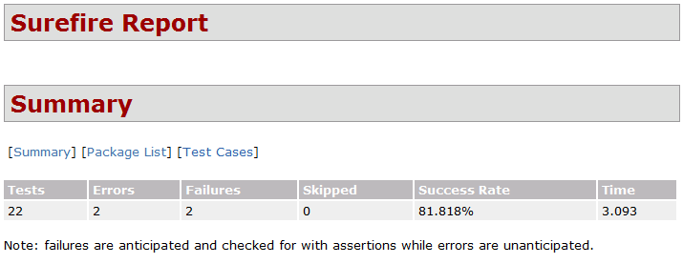
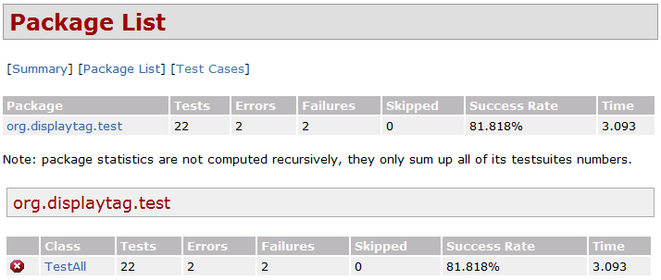
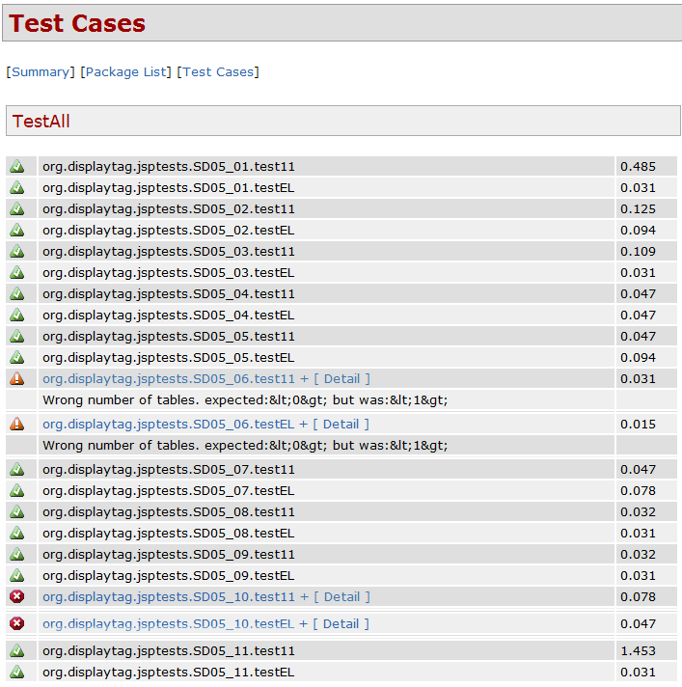
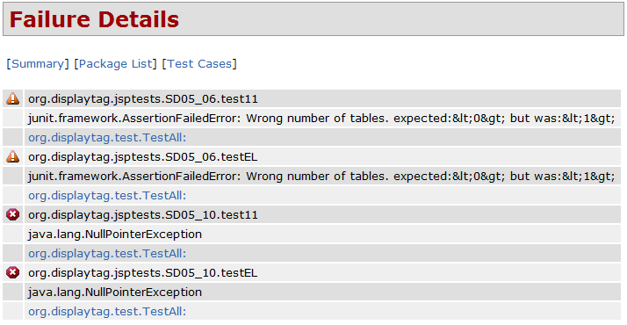

Structural Test Results

Description
This section contains the results of testing that was performed on the modules that were previously identified in Section 15.2. These tests were executed using the jUnit framework along with HTTPUnit.

Testing Results
The tests were executed on December 7, 2008 at 1:28 PM EST by Eric Borisow. The following table contains the results of the tests:

Test Case | Name | Result | Incident
SD05-ST01-01 | ExcludedParams parameter is null | Passed
SD05-ST01-02 | ExcludedParams parameter contains ‘*’ value | Passed
SD05-ST01-03 | ExcludedParams parameter contains ‘*, myParam’ value | Passed
SD05-ST01-04 | ExcludedParams parameter contains ‘*, *’ value | Passed
SD05-ST01-05 | ExcludedParams parameter contains ‘* *’ value | Passed
SD05-ST01-06 | ExcludedParams parameter contains ‘myParam, *’ value | Failed | SD06-03
SD05-ST01-07 | ExcludedParams parameter contains ‘myParam’ value | Passed
SD05-ST01-08 | RequestURI is null, dontAppendContext is true | Passed
SD05-ST01-09 | RequestURI is null, dontAppendContext is false | Passed
SD05-ST01-10 | RequestURI is not null, dontAppendContext is true | Passed
SD05-ST01-11 | RequestURI is not null, dontAppendContext is false | Failed | SD06-04

Below is the output of the jUnit tests. Note the two test failures that occurred during the tests.
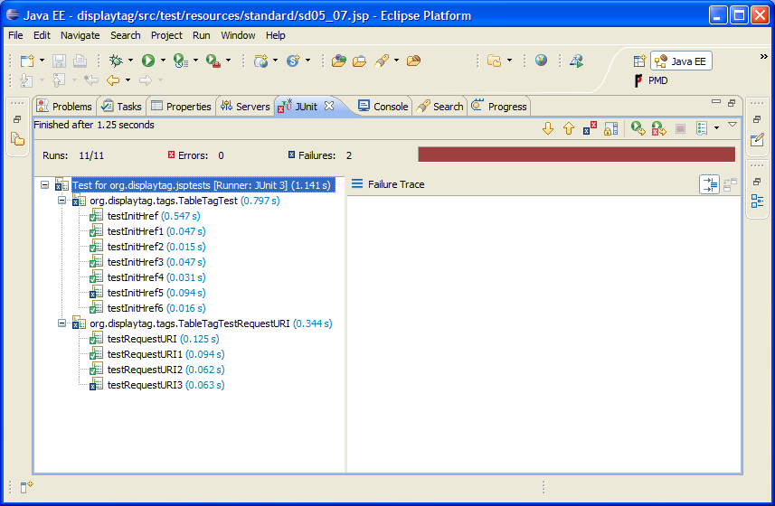

Test Incidents

SD06-01 – Invalid List Object Incident

Summary
This incident occurred while performing test SD05-06 that tests the system’s ability to handle an Invalid List object.

Incident Description
The primary object that is passed into the system is a List-type object. The object may be one of several types. It may be a List, a Set, an Array or just about any object that implements the Collection interface. This test was checking to see how the system would handle a completely invalid object. In fact, it was a java.util.Object object type. The system should have printed the message that there were no items in the list. Instead, the system printed the toString() method from the object. This results in some arbitrary text message that was displayed to the end user instead of an empty table.
The stack trace from the test:
junit.framework.AssertionFailedError: Wrong number of tables. expected:&0& but was:&1&
at junit.framework.Assert.fail(Assert.java:47)
at junit.framework.Assert.failNotEquals(Assert.java:282)
at junit.framework.Assert.assertEquals(Assert.java:64)
at junit.framework.Assert.assertEquals(Assert.java:201)
at org.displaytag.jsptests.SD05_06.doTest(SD05_06.java:47)
at org.displaytag.test.DisplaytagCase.test11(DisplaytagCase.java:61)

Impact
This failure did not affect testing. The automated testing continued without incident.

SD06-02 – Invalid PageContext Attribute Test Case

Summary
The incident occurred while performing test SD05-10 that is a test designed to check the system’s ability to handle an invalid PageContext attribute that is passed into the Carpool table element.

Incident Description
The display:table element permits an attribute named id to be used to specify the name of an attribute that will contain the current object that is being processed during the loop. This test was testing whether or not the system would be able to handle an object with a different name than that specified in the id attribute. Unfortunately, the system produces a NullPointerException error instead of failing gracefully.
The stack trace from the test:
java.lang.NullPointerException
at org.apache.jsp.standard.sd05_005f10_jsp._jspService(org.apache.jsp.standard.sd05_005f10_jsp:99)
at org.apache.jasper.runtime.HttpJspBase.service(HttpJspBase.java:97)

Impact
The failure did not affect the testing process. The test script completed without incident.

SD06-03 - ExcludedParams parameter contains ‘myParam, *’ value

Summary
The incident occurred while performing test SD05-ST01-06 that is a module test that was checking to see what they system would do when the excludedparams parameter contained a parameter name and a * character.

Incident Description
The excludedparams parameter is a setting that the user can specify in a properties file for the system. The system is typically expecting either a wild card (*) or a named parameter. The functionality is supposed to remove either all of the parameters (in the case of the wild card) or the parameters named from the URL that is used for the paging controls. This test was analyzing the system result when a named parameter was passed with the wild card character.
The system should have responded by not removing any parameters from the list. However, the system returned the URL with only one parameter.

Stack Trace from test:
junit.framework.ComparisonFailure: expected:<...2> but was:<...1>
at junit.framework.Assert.assertEquals(Assert.java:81)
at junit.framework.Assert.assertEquals(Assert.java:87)
at org.displaytag.tags.TableTagTest.testInitHref5(TableTagTest.java:367)

Impact
The failure did not affect the testing process since we were analyzing a module. The automated script continued with any issue.

SD06-04 - RequestURI is not null, dontAppendContext is false

Summary
The incident occurred while performing test SD06-04 that is a module test that was designed to check the system response when the requestURI specified by the user contained a value and the dontAppendContext parameter was false.

Incident Description
When the system generated the URL to be used for paging controls, the RequestURI parameter allows the user to specify their own URI in place of the base URI of the URL string. The dontAppendContext parameter is supposed to indicate that the user would like append the RequestURI to the current context (base URI) of the URL. In this test, we wanted to check the system behavior when a value was specified for the RequestURI and the dontAppendContext parameter was set to false. We were expecting the URL that was returned from the method to equal the new context, but for some reason the base URL was returned and our context was ignored.
Stack trace from test:
junit.framework.ComparisonFailure: expected:<http://localhost/displaytagtes...> but was:</newContex...>
at junit.framework.Assert.assertEquals(Assert.java:81)
at junit.framework.Assert.assertEquals(Assert.java:87)
at org.displaytag.tags.TableTagTestRequestURI.testRequestURI3(TableTagTestRequestURI.java:201)

Impact
The failure did not affect the testing process since we were analyzing a module and the system did not crash. The automated script continued with the remaining tests.

Appendix A – References
[1] Sinha, Saurabh and Harrold, Mary Jean, Criteria for Testing Exception-Handling Constructs in Java Programs, Proceedings of the IEEE International Conference on Software Maintenance, 1999, Washington, DC, USA
[2] de Melo, Ana C. V., Nunes, Paulo R. F., Xavier, Kleber S., Towards Veriﬁcation and Testing of Java Programs, Proceedings of the 2008 ACM symposium on Applied computing, 2008, Fortaleza, Ceara, Brazil
[3] Gutiérrez, Javier J.; Escalona, María J.; Jesús Torres, Manuel Mejías, An Approach to Generate Test Cases from Use Cases, SESSION: Session 5: web system architectures, Proceedings of the 6th international conference on Web engineering, 2006, Palo Alto, California, USA
[4] Murlewski, Jan; Wojciechowski, Jaroslaw; Sakowicz, Bartosz; Napieralski, Andrzej; Comprehensive Approach to Web Applications Testing and Performance Analysis, CAD Systems in Microelectronics, 2007. CADSM '07. 9th International Conference - The Experience of Designing and Applications of, 19-24 Feb. 2007, Lviv, Ukraine
[5] Chen, M. and Kao, H. M. 1999. Testing Object-Oriented Programs An Integrated Approach. In Proceedings of the 10th international Symposium on Software Reliability Engineering (November 01 - 04, 1999). ISSRE. IEEE Computer Society, Washington, DC, 73.
[6] Ricca, Filippo and Tonella, Paolo, Web Testing: a Roadmap for the Empirical Research, Web Site Evolution, 2005. (WSE 2005). Seventh IEEE International Symposium on, 26 Sept. 2005, Trento, Italy
[7] Wee Kheng Leow; Siau Cheng Khoo; Yi Sun, Automated Generation of Test Programs From Closed Specifications of Classes and Test Cases, Software Engineering, 2004. ICSE 2004. Proceedings. 26th International Conference on Volume , Issue , 23-28 May 2004
[8] Software Engineering Technical Committee of the IEEE Computer Society, IEEE Standard for Software Test Documentation, Retrieved from http://ieeexplore.ieee.org/servlet/opac?punumber=5976 on December 3, 2008, 16 Dec. 1998
[9] Jorgensen, Paul; Software Testing: A Craftsman’s Approach; Auerbach Publications, 15 Feb 2008

Appendix B – Sample JSP Test Page
Here is a sample JSP Test Page that was used to perform one of the unit tests.

<jsp:root version="1.2" xmlns:jsp="http://java.sun.com/JSP/Page"
xmlns:display="urn:jsptld:http://displaytag.sf.net">
<jsp:directive.page import="org.displaytag.test.SampleValue"/>
<jsp:text> <![CDATA[<!DOCTYPE html PUBLIC "-//W3C//DTD XHTML 1.0 Strict//EN"
"http://www.w3.org/TR/xhtml1/DTD/xhtml1-strict.dtd"> ]]> </jsp:text>
<jsp:directive.page contentType="text/html; charset=UTF8"/>
<html xmlns="http://www.w3.org/1999/xhtml" lang="en">
<head>
<meta http-equiv="content-type" content="text/html; charset=UTF-8" />
<title>Carpool unit test</title>
</head>
<body>
<jsp:scriptlet> <![CDATA[
java.util.List test = new java.util.ArrayList();
test.add(new org.displaytag.test.SampleValue());
request.setAttribute( "test", test );
]]> </jsp:scriptlet>
<display:table name="requestScope.test" id="table">
<display:column>
<jsp:expression>((SampleValue)pageContext.getAttribute("table")).getRed()</jsp:expression>
</display:column>
</display:table>
</body>
</html>
</jsp:root>

Appendix C – Sample Test Case class
Here is a sample of the TestCase class that is used to perform assertions on the JSP Page:

package org.displaytag.jsptests;

import org.displaytag.test.DisplaytagCase;

import com.meterware.httpunit.GetMethodWebRequest;
import com.meterware.httpunit.TextBlock;
import com.meterware.httpunit.WebRequest;
import com.meterware.httpunit.WebResponse;
import com.meterware.httpunit.WebTable;

/**
* Tests for basic displaytag functionalities.
* @author Eric Borisow
*/
public class SD05_07 extends DisplaytagCase
{

/**
* @see org.displaytag.test.DisplaytagCase#getJspName()
*/
public String getJspName()
{
return "sd05_07.jsp";
}

/**
* Verifies that the generated page contains a table with the expected number of columns.
* @param jspName jsp name, with full path
* @throws Exception any axception thrown during test.
*/
public void doTest(String jspName) throws Exception
{

WebRequest request = new GetMethodWebRequest(jspName);
WebResponse response = runner.getResponse(request);

if (log.isDebugEnabled())
{
log.debug("RESPONSE: " + response.getText());
}

WebTable[] tables = response.getTables();
assertEquals("Wrong number of tables.", 1, tables.length);
assertEquals("Empty list message is incorrectly displayed", false, response.getText().indexOf("There are no results.") > 0);

assertEquals("Wrong number of generated columns.", 1, tables[0].getColumnCount());
assertEquals("Wrong number of generated rows.", 2, tables[0].getRowCount());

assertEquals("red", tables[0].getCellAsText(1, 0));
}
}

